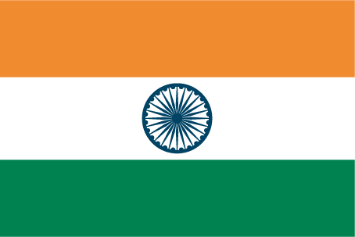
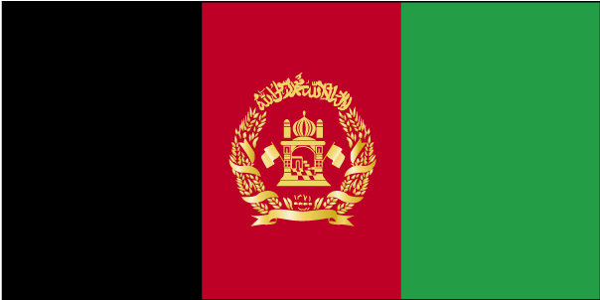
SOUTH ASIA INITIATIVE TO END VIOLENCE AGAINST CHILDREN
(SAIEVAC)

South Asia Call

for

Action On Ending Violence against Children

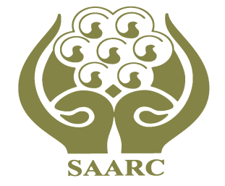

SAIEVAC

South Asia Follow Up Regional Consultation
Organized and Showcased by SAIEVAC Regional Secretariat
Supported by SACG and in Collaboration with UN SRSG
Hosted by the Government of Srilanka

South Asia Call for Action On Ending Violence against Children

-----------------------------------------------------------------------------------------------------------------

We, the participants at the South Asia Follow Up Regional Consultation on the UN Study on Violence against Children, representatives from governments, non-governmental and other civil society organizations, regional and international organizations, and children, have gathered in Colombo, Sri Lanka, on 28 to 30 May 2012, to take stock of progress made since the Regional Consultation on Violence Against Children in South Asia, Islamabad, Pakistan, 19-21 May 2005 and the endorsement of the UN Study on Violence against Children by the General Assembly in 2006, in order to strengthen measures and processes aimed at ending violence against all children in all settings.

Acknowledging SAIEVAC as an apex body of SAARC;

Reaffirming overall efforts by all stakeholders to end all forms of violence against children in all settings, and more specifically commitments by Governments to the Convention on the Rights of the Child and its Optional Protocols, the Convention on the Elimination of All Forms of Discrimination against Women, the SAARC Social Charter, the SAARC Convention on Regional Arrangements for the Promotion of Child Welfare, the SAARC Convention on Preventing and Combating Trafficking in Women and Children for Prostitution, the SAARC Framework for the Protection, Care and Support of Children Affected by HIV/AIDS, the SAARC Development Goals (SDGs) and the Millennium Development Goals (MDGs);

Renewing the commitment made by our Ministers in the Rawalpindi Resolution on Children of South Asia (1996) and the Colombo Statement on Children of South Asia (2009), and the Recommendations endorsed at the Ministerial Meeting of SAIEVAC in June 2010 in Kathmandu;

Recalling the Recommendations from the Regional Consultation on Violence Against Children in South Asia (2005) and the subsequent Recommendations from the UN Study on Violence against Children; the South Asia Forum (SAF) Regional Preparatory Consultation for the World Congress III against Sexual Exploitation of Children and Adolescents (2008), the Kathmandu Commitment to Action for Ending Violence against Children (2010); the Technical Consultations on Legal Reform and Corporal Punishment (2010) and Child-friendly Services and Care Standards (2011) including those made by children; the Beijing Declaration on South-South Cooperation for Child Rights in the Asia Pacific Region (2010) and the Assessment of Progress in the SAARC Decade of the Rights of the Child (2001-2010) presented at the 17th SAARC Summit in Addu City (2011);

Renewing our determination as key stakeholders to consistently promote and practice a rights-based approach and collaboration to prevent, mitigate and respond to violence against children;

Noting with appreciation the collaboration with the UN Special Representative of the Secretary General on Violence against Children for the Follow Up Regional Consultation on Violence against Children and supporting the mandate of the office of the SRSG,

Recognizing that, despite the progress made across South Asia to address violence against children, children continue to experience serious forms of violence and child protection challenges, including child labour, corporal punishment, sexual abuse and exploitation, child trafficking, migration and displacement, imprisonment, discrimination related to HIV/AIDS, disability, minorities, orphans, street children and children in need of care and protection, as well as various forms of harmful practices such as child marriage,

Acknowledging the detrimental and often long term impact of child abuse and violence, not just at an individual level but also on the socio-economic development of countries and that violence against children is not a private/family matter but a public issue concerning society at large,

Also acknowledging the launch of campaign by SAIEVAC against corporal punishment of children in all settings and noting that no violence against children is justifiable and that all violence against children is preventable,

To achieve our joint goals and shared vision that children throughout South Asia enjoy their right to be protected from all forms of violence, abuse, exploitation, neglect and discrimination, we collectively call for the following urgent actions to realize the rights of all children:

- Develop and strengthen equitable national and local child protection systems including laws, policies and standards; that prevent, mitigate and respond timely and appropriately to all forms of violence and to ensure that mechanisms and services are accessible to all children.

- Develop and implement laws and policies that focus on safeguarding children from potential harm and that ban all forms of violence against children in all settings, including home and family, schools and educational settings, care and justice systems, work settings and the community;

- Address social norms and practices that are harmful to children by promoting social change to end violence, exploitation, abuse and neglect of children;

- Consolidate and validate a national system for disaggregated data collection, analysis, dissemination, and a systematic research agenda to inform policy development and resource mobilization to protect children from violence;

- Review/adopt and implement a national plan of action to integrate the recommendations of the UN Study on Violence against Children and SAIEVAC work plan and develop a baseline to be able to measure progress;

- Invest in and evolve policies and processes to strengthen the participation of children in decisions, through supporting and strengthening child-led organizations/forums;

- Cooperate through structure, processes and resources in the best interest of children to address cross-border issues, such as trafficking, missing children, HIV and AIDS and drug abuse and repatriation;

- Develop mechanisms to address the safety of children with reference to the use and engagement with digital technologies;

- Share lessons and good practices and explore new opportunities for Cooperation to advance the protection of children through establishing a SAIEVAC centre of excellence on violence against children;

- Strengthen regional and country-level cooperation and coordination between governments, NGOs, CSOs, children and young people, academia, independent human/child rights institutions, Parliamentarians, religious leaders, media, private sector as well as bilateral and multilateral agencies including UN agencies/INGOs;

- Expedite the establishment of National SAIEVAC Chapters to accelerate existing efforts to end violence against children;

- Contribute to the establishment and implementation of an operational framework/mechanism for monitoring and accountability at all levels to stimulate and accelerate effective realization of the actions mentioned above.

We unanimously adopt this, South Asia Call for Action on Ending Violence against Children. We thank the Government of Sri Lanka for their hospitality as hosts of the meeting, SAIEVAC for organizing it, the UN Special Representative of the Secretary-General on Violence against Children for her collaboration and the SACG for its support to the meeting.

Colombo, date: 30 May 2012

